30 Mar 2025

Song 1 - Only a holy God
Song 2 - Holy Holy Holy
Song 3 - Kids song - Mighty mighty Saviour
Song 4 - In Christ alone
Song 5 - Closing song - All I have is Christ

Only a Holy God D
[Intro]
Bm D G D
(repeat x2)

[Verse 1]
Bm D G D
Who else commands all the hosts of heaven
Bm D G D
Who else could make every king bow down
Bm D G D
Who else can whisper and darkness trembles
G A D
Only a Holy God

[Verse 2]
Bm D G D
What other beauty demands such praises
Bm D G D
What other splendour outshines the sun
Bm D G D
What other majesty rules with justice
G A D
Only a Holy God

[Chorus 1]
Bm G
Come and behold Him
D A
The One and the Only
Bm G
Cry out, sing holy
D A Bm
Forever a Holy God
G A D( Bm)
Come and worship the Holy God
[Tag]
Bm D G D
(repeat x2)

[Verse 3]
Bm D G D
What other glory consumes like fire
Bm D G D
What other power can raise the dead
Bm D G D
What other name remains undefeated
G A D
Only a Holy God

CHORUS X2

[Tag]
Bm D G D
(repeat x3)
G A D

[Verse 4]
Bm D G D
Who else could rescue me from my failing
Bm D G D
Who else would offer His only Son
Bm D G D
Who else invites me to call Him Father
G A D
Only a Holy God
G A D
Only my Holy God

CHORUS X2

HOLY, HOLY, HOLY (C37)

Verse 1
C
Holy, Holy, Holy,
F
Lord God Almighty!
Em Am
Early in the morning,
D7 G7
Our song shall rise to Thee;
C
Holy, Holy, Holy!
F C
Merciful and Mighty!
Em Am
God in Three Persons,
Dm7 G7 C
Blessed Trinity!

Verse 2
C
Holy, Holy Holy!
F
All the saints adore Thee,
Em Am
Casting down their golden crowns
D7 G7
Around the glassy sea;
C
Cherubim and seraphim
F C
falling down before Thee,
Em Am
Which wert and art and
Dm7 G7 C
evermore shalt be.

Verse 3
C
Holy, Holy Holy!
F
Tho’ the darkness hide Thee,
Em Am
Tho’ the eye of sinful man
D7 G7
Thy glory may not see;
C
Only Thou art holy
F C
there is none beside Thee,
Em Am
Perfect in pow’r, in
Dm7 G7 C
love and purity.

Verse 4
C
Holy, Holy Holy!
F
Lord God Almighty!
Em Am
All Thy works shall praise Thy name
D7 G7
In earth and sky and sea;
C
Holy, Holy, Holy!
F C
Merciful and Mighty
Em Am
God in Three Persons,
Dm7 G7 C
blessed Trinity!

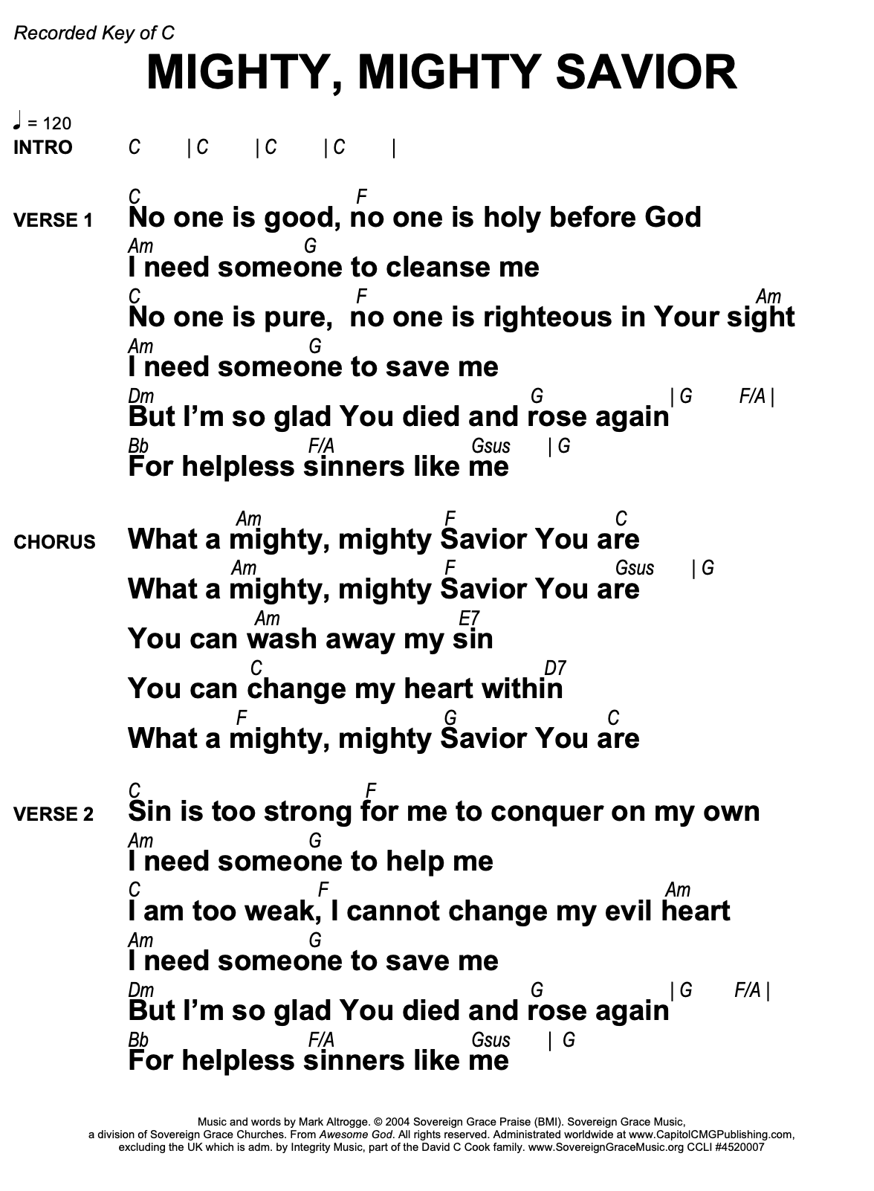
IN CHRIST ALONE

Intro E A C#m A (x2)

(Verse 1)
E C#m B
In Christ alone my hope is found
E/G# A B E
He is my light my strength my song
A E C#m B
This Cornerstone, this solid Ground
E/G# A B E
Firm through the fiercest drought and storm
E/G# A C#m B
What heights of love , what depths of peace
E/G# A C#m B
When fears are stilled when strivings cease!
A E C#m B
My Comforter my All in All
E/G# A B E
Here in the love of Christ I stand
E A C#m A E A C#m A
Whoa Whoa Whoa Whoa

E C#m B
There in the ground His body lay
E/G# A B E
Light of the world by darkness slain
A E C#m B
Then bursting forth in glorious Day
E/G# A B E
Up from the grave He rose again!
E/G# A C#m B
And as He stands in victory
E/G# A C#m B
Sin's curse has lost its grip on me
A E C#m B
For I am His and He is mine
E/G# A B E
Bought with the precious blood of Christ
E A C#m A E A C#m A
Whoa Whoa Whoa Whoa
E C#m B
No guilt in life no fear in death
E/G# A B E
This is the power of Christ in me
A E C#m B
From life's first cry to final breath
E/G# A B E E (Extra bar)
Jesus commands my desti - ny
E/G# A C#m B
No power of hell no scheme of man
E/G# A C#m B
Can ever pluck me from His hand
A E C#m B
Till He returns or calls me home
E/G# A B E E
Here in the love of Christ I'll stand!

E/G# A C#m B
And as He stands in victory
E/G# A C#m B
Sin's curse has lost its grip on me
A E C#m B
For I am His and He is mine
E/G# A B E E
Bought with the precious blood of Christ

A E C#m B
Till He returns or calls me home
E/G# A B C#m
Here in the Power of Christ I'll stand!

E/G# A B E
Here in the Power of Christ We stand!

All I Have Is Christ

[Intro]
||: Am C/E | F C/E | F G | C :|| | C x2

[Verse 1]
G Am
I once was lost in darkest night
F Am
Yet thought I knew the way
Dm F
The sin that promised joy and life
G C
Had led me to the grave
C/E F
I had no hope that You would own
Dm Am
A rebel to Your will
C/E F
And if You had not loved me first
Am G
I would refuse You still

[Instrumental]
||: Am C/E | F C/E | F G | C :|| | C

[Verse 2]
G Am
But as I ran my hell-bound race
F Am
Indifferent to the cost
Dm F
You looked upon my helpless state
G C
And led me to the cross
C/E F
And I beheld God's love displayed
Dm Am
You suffered in my place
C/E F
You bore the wrath reserved for me
Am G
Now all I know is grace

[Chorus] (Soft, build on 2nd)
F C G Am
Hallelujah! All I have is Christ
F Am G C
Hallelujah! Jesus is my life x2

[Intro]
||: Am C/E | F C/E | F G | C :|| | C x2

[Verse 3] (Soft)
G Am
Now, Lord, I would be Yours alone
F C
And live so all might see
Dm F
The strength to follow Your commands
G C
Could never come from me
C
Oh Father, use my ransomed life

In any way You choose
Am F
And let my song forever be
Am G
My only boast is You

[Chorus] Loud
F C G Am
Hallelujah! All I have is Christ
F Am G C
Hallelujah! Jesus is my life x2

[Outtro]
||: Am C/E | F C/E | F G | C :|| | C x2

